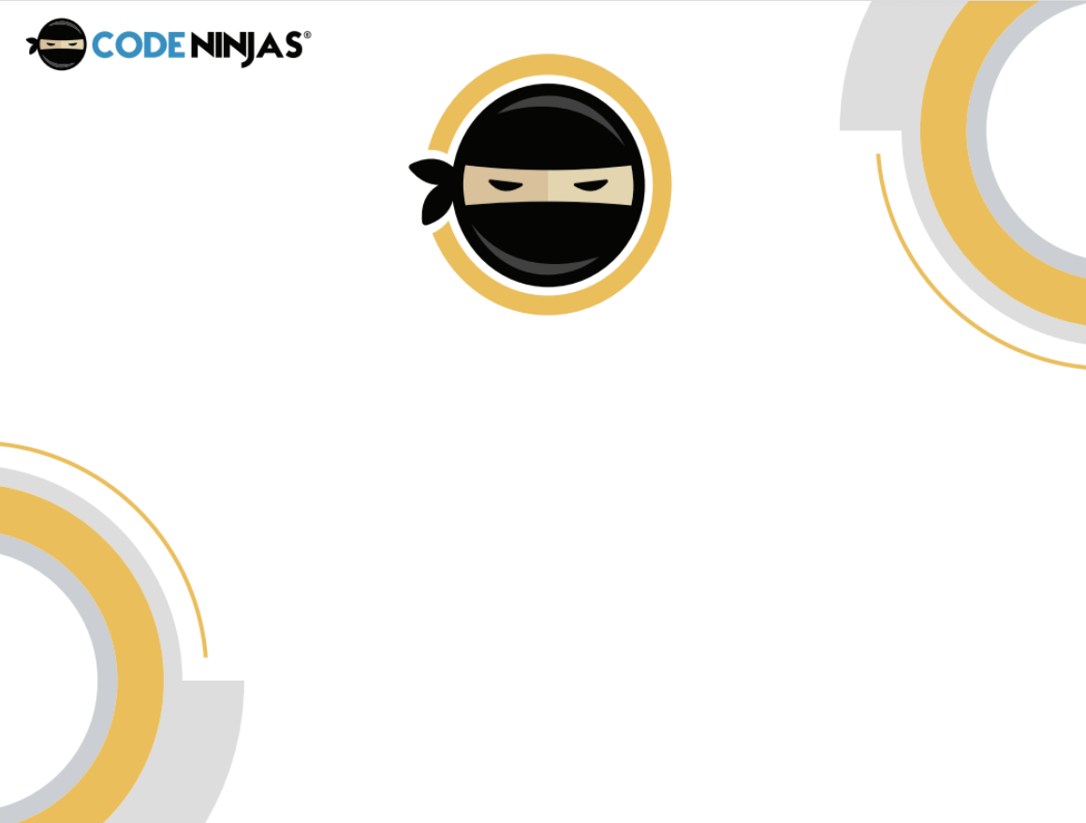

~ Sensei Dereece



~ Sensei Dereece